**Terms of Reference**

For

Development of Dzongkhag (District) Brand and Messaging

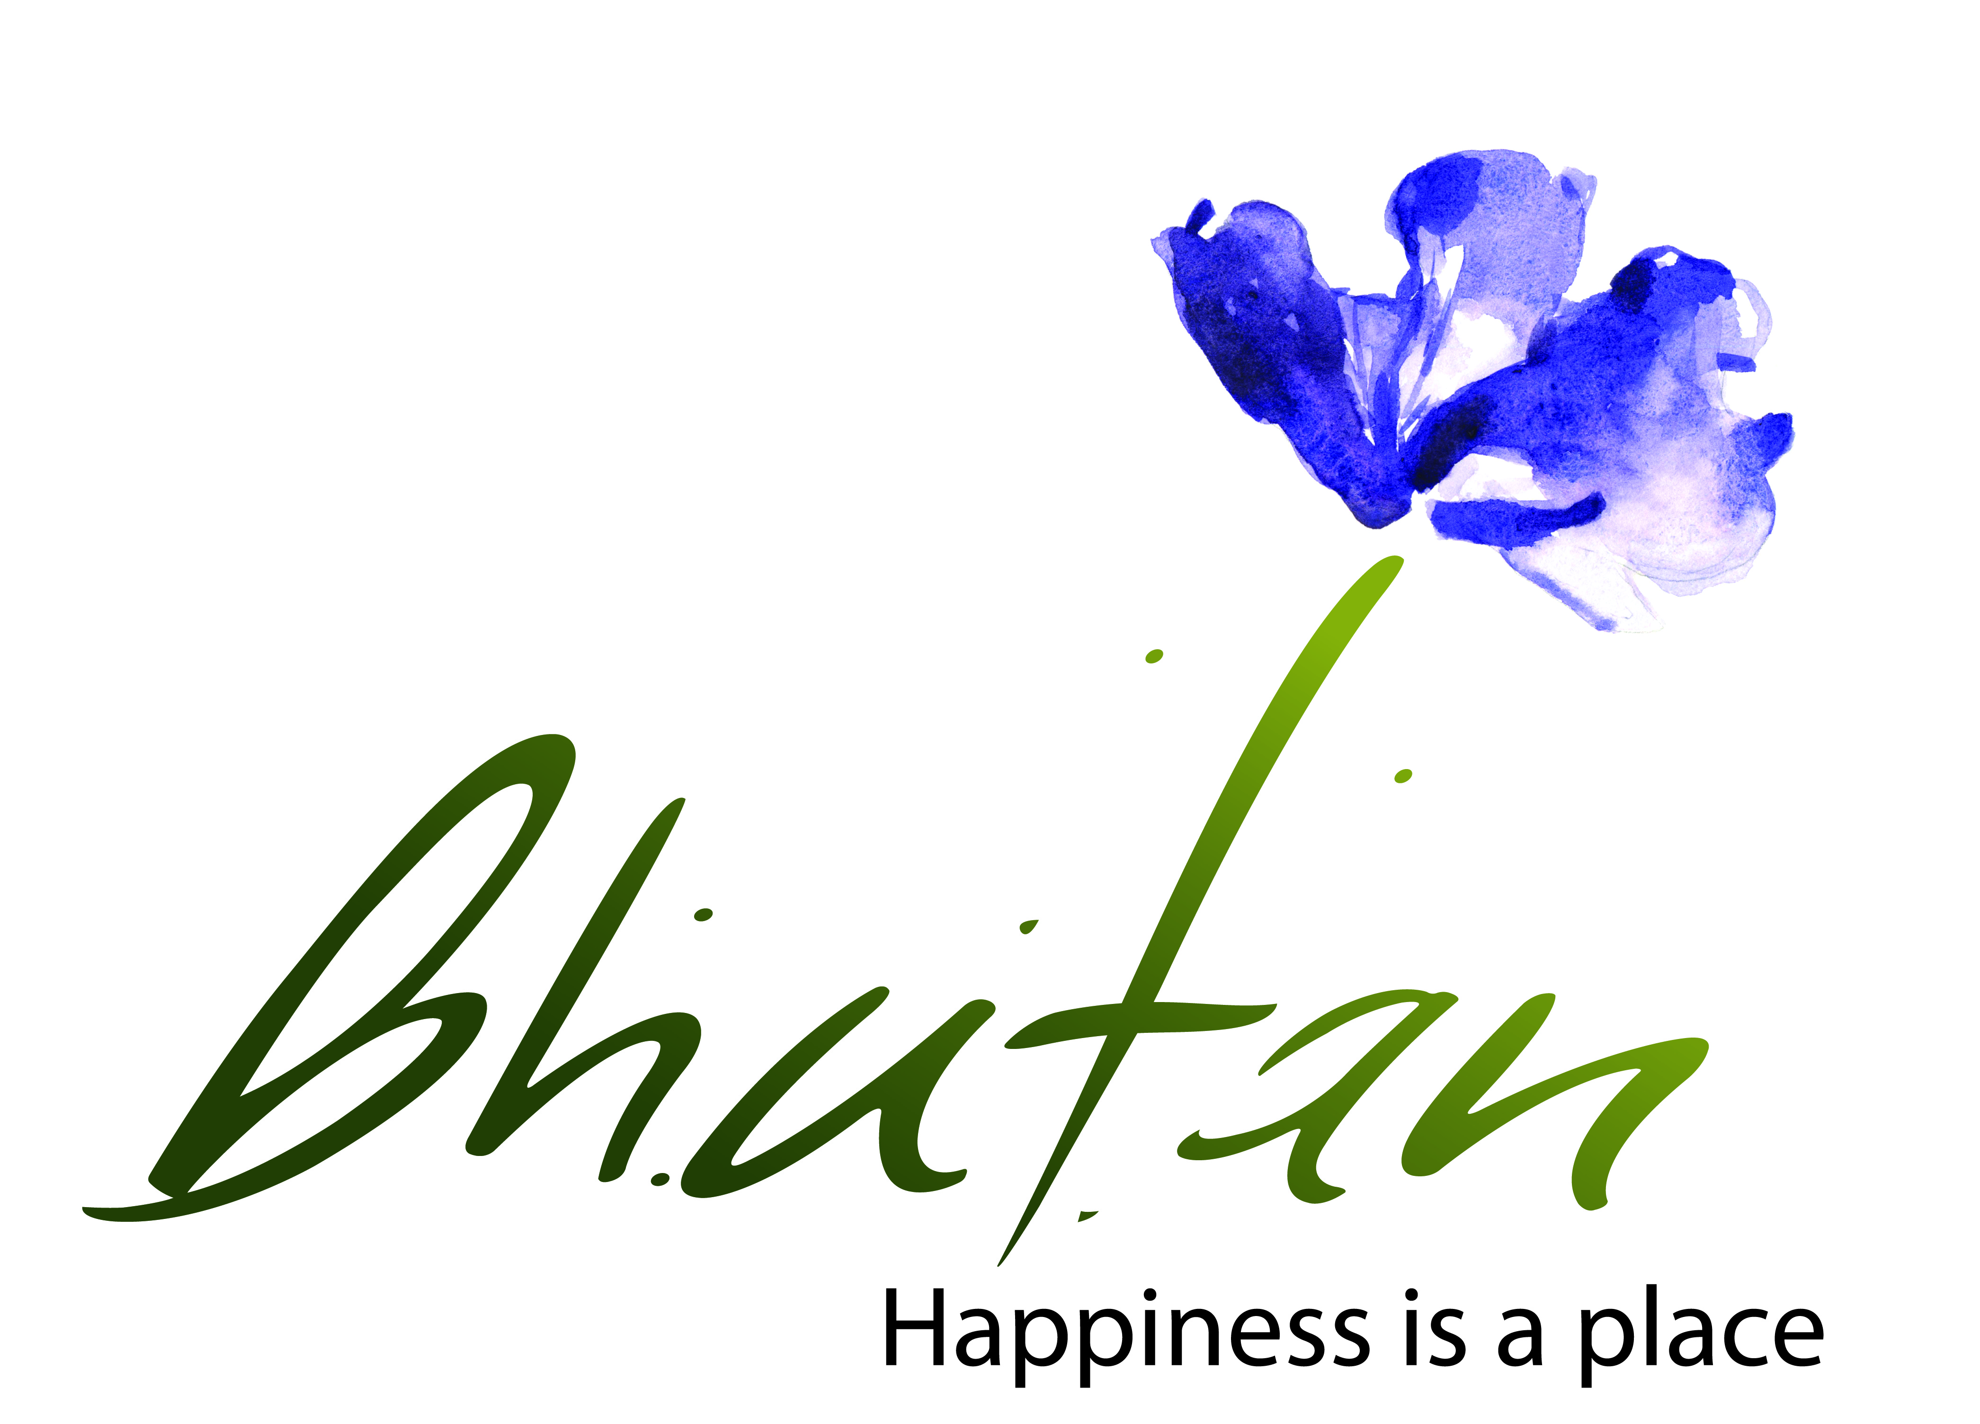

# Introduction

This ‘Terms of Reference’ is for the purpose of hiring brand consultants, international or/and national, to assist and lead in developing creatives (artwork) to develop dzongkhag brand logo, tagline, brand messaging, marketing and promotion plan, and promotional videos.

1. **Objective**

* To develop creavtives (artwork) for brand logo and tagline for five districts
* To develop marketing and communication plan
* To develop promotional videos

1. **Scope of work**

The brand consultants will develop brand logo, tagline, and the following for the five districts. The consultants must have valid license to carry out this project and the team must comprise of more than one person that is capable of executing this project. The team can be a mix of international and Bhutanese.

*1. Planning and Strategy*

1. Prepare a plan to develop creatives (artwork) for brand logo, tagline, and brand messaging. This plan must be approved before the execution of this assignment.
2. Carry out research to develop creatives (artwork) for brand logo and tagline.
3. Lead industry consultation meetings to understand the existing and future perception on each district to develop creative for Brand logo and messaging for the five districts.
4. Conduct research to develop marketing and promotion plan.
5. Develop concepts for advertising: print, outdoor, online, radio, and other collateral materials.

*2. Deliveries: Creative elements and collaterals*

1. Develop and design logo and tagline for five districts.
2. Develop brand guideline and architecture.
3. Develop marketing and promotional plan outlining strategic and tactical initiatives to create a distinct positioning for five districts.
   1. This should include communication plan
4. Develop promo video (1-2 minutes) each for five districts
5. Photographs (High Definition). The photographs must be segregatted by category-wise and all photographs must be colour corrected.
6. Video clips of different attractions and activities. The clips must be colour corrected and ready to use.
7. Submit a final completion report with final deliverables.
8. Overall coordination/direction for this project.
9. **Selection criteria**

|  |  |  |
| --- | --- | --- |
|  | **Area** | **Points** |
| 1 | Qualification of the team | 70% |
| 2 | Experience of the team |
| 3 | Deliveries produced |
| 4 | Equipment |
| 5 | Financial | 30% |

1. **Timeline**

The brand consultant (s) will complete the above work and submit the final report to the Tourism Council of Bhutan after one month of commencement (signing of the contract) this assignment.

1. **Payment**

|  |  |  |
| --- | --- | --- |
|  | **Description** | **%** |
| 1 | Initial payment during the signing of the contract | 20% |
| 2 | Upon finalization of the overall plan (strategy) for execution | 20% |
| 3 | Upon submission of all the creatives (artwork) and other communication creatives | 50% |
| 4 | Upon submission of the final report | 10% |

1. **Copyright**

The Tourism Council of Bhutan will have full copyright of the creative and other deliverables.

1. **Application**

The last date for the submission of the tender document is at 3:00PM, 5th December 2019.

1. **Contact**

Please contact the following for more information;

Mr. Damcho Rinzin

[damchorinzin@tourism.gov.bt](mailto:damchorinzin@tourism.gov.bt)

+975 17141919